

**Coalfield strategy document**

**Bilston Glen area**

June 2014

**Version History**

|  |  |  |  |
| --- | --- | --- | --- |
| **Version** | **Date** | **Authors** | **Comments** |
| 2 | 11 June 2014 | Lee Wyatt  Ian Watson | Draft for comment |

**Introduction**

This document outlines the current known details, and risks associated with rising mine water in the Bilston Glen coalfield area in Midlothian, Scotland. The document also summarises any key potential stakeholders, followed by options and recommendations as part of the forward strategy for preventing risks from occurring.

**Summary and History**

Bilston Glen area is located to the south of Edinburgh. The mining extent and interconnected mine workings cover part of the Midlothian Coalfield between Loanhead to the west and Dalkeith the east (see figure 1). The mining area is a synclinal basin being bounded by outcrops on three sides, with the northern extent by a large fault (200m throw) and includes both shallow and deep mine workings, with the deepest parts reaching approx. 700mBOD in the centre of the block. Mining in the block ceased when Bilston Glen Colliery closed in 1989.



Reproduced by permission of Ordnance Survey on behalf of HMSO. © Crown copyright and database right 2012. All rights reserved. Ordnance Survey Licence number: 100020315

**Figure 1** – Location map for Bilston Glen area, selected monitoring sites and potential discharge points

Recent specific studies for the Bilston Glen area include reports undertaken by IMC in 1998, and a more recent one by URS in 2014; the area was covered in the UK Overview Summary Report (WYG, 2012). The 1998 report identified possible sites of discharges including the Burghlee Day Level (approx. 110mAOD) (and possibly Dryden Day Level) along Bilston Glen Burn at Loanhead; through the workings to the Old Fordell Junkies Day Level (48mAOD) and Bryans Day Level (*c.* 51mAOD) at Ochre Burn. Rising mine water has been observed at Bilston Glen shaft since 2003 (see figure 2); projections have been made to determine likely timings for this water to reach the lowest possible discharge location (Old Fordell Junkies Day Level). These projections give a date for a discharge of between 2017 and 2020.

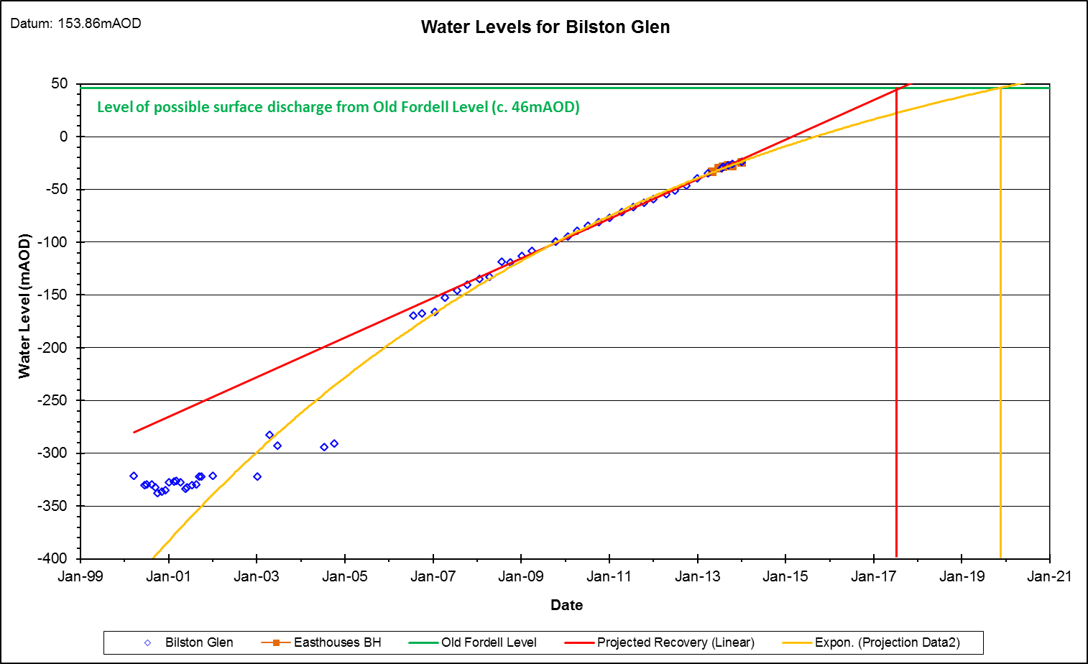

**Figure 2** – Mine water levels in the Bilston Glen area (note: Mouth of Old Fordell is approx. 35mAOD; adit connection to workings is believed to be approx. 46mAOD)

The site(s) of any future schemes are to be determined, although possible sites have been highlighted in the IMC report; however these sites may no longer be appropriate. The preventative scheme for Bilston Glen is currently programmed for 2015/2016 or 2016/2017. Although no exact location or method has been identified, a preventative scheme is likely to consist of pumping (Bilston Glen Shaft or a new borehole) and treatment.

In 2013 a borehole was sunk along the eastern edge of the mining block at Easthouses; this proved the water level was similar to that at Bilston Glen; and probably confirms that the connecting roadways in the deepest workings remain open and allowing flow across the coalfield. Currently, there are no other monitoring sites with the area of rising mine water.

In the centre of the basinal coalfield workings are very deep, and are overlain by separate workings at much shallower depth. These shallower workings are monitored at Elginhaugh, Glenesk (discharges) and Whitehill borehole (water level). These higher level workings have been fully recovered for many years, and are believed to be hydraulically separate from the Bilston Glen workings which are recovering at depth.

**Risks**

With the rising mine water situation at Bilston Glen, there are a number of associated risks; some of which have been identified through previous studies. The known possible risks although not exclusively include:

* Gravity mine water discharge at Old Fordell (Level where adit is believed to meet the workings of *c.*46mAOD) – The Bilston Glen area is believed to be connected via mining connections to the Junkies Day Level. There is an existing discharge from the adit, and the discharge is on the ranked SEPA list of remedial schemes at number 5, planned for WFD cycle 2. There is a risk the flows and iron loading could increase in the future, thus resulting in a greater impact in the River South Esk. This is likely to occur between 2017 and 2020. Monitoring of the discharge flow and quality, and water level in an associated airshaft should be commenced.
* Gravity mine water discharge from Bryans Day Level (*c*.51mAOD) – Similar to the Junkies Day Level, there is potential for ochreous discharge to occur from this day level, in to the Ochre Burn. This is likely to occur slightly later than at Old Fordell, although the timing/extent of this is uncertain and will depend on flow paths to Old Fordell and Bryans Day Level.
* Increase in flows at Elginhaugh (*c.*48mAOD) – The Polton section of Bilston Glen area is believed to be discharging to the River North Esk via the Elginhaugh (Eldin) Day Level. The Elginhaugh discharge is considered to be draining separate overlying mine workings. Thus, the potential for increased flows to Elginhaugh are uncertain although could be considered to be a low risk.
* Gravity mine water discharge to Bilston Glen Burn (*c.*110 to 130mAOD) – There is potential for some flows occurring form the Burghlee Day Level and shafts, these are located below the Bilston Glen tip. The nature of any treatment of these adits and shafts under the tip is uncertain; hence the potential impacts on the tip are also uncertain.
* Release of mine gas – There is potential for mine gas to be pushed up with the rising mine water. The exact nature, extent or areas for this to occur are uncertain, however are likely to occur in areas of un-flooded workings and or where worked seams outcrop to surface.
* The current quality of the Bilston Glen mine water and flow rates (filling the workings) are unknown, hence the likely impact on any features is also unknown.

**Stakeholders**

Key stakeholders include:

* Scottish Environmental Protection Agency (SEPA) – Responsible for regulating any pollution regarding surface water and groundwater. SEPA’s key driver is to avoid deterioration of status of water bodies assessed under Water Framework Directive. Any future remedial scheme will require significant liaison with SEPA regarding the works, and licences.
* The Coal Authority Public Safety and Subsidence Department – Potential for increased enquiries and hazards.
* Local Authorities – May receive complaints from local residents and industry regarding ochreous discharges and other related issues. Any future schemes will also require significant amount of correspondence and planning with local authorities.
* Surface and or groundwater abstractors – Include private and public supplies, where there may be a potential to affect their wells or abstractions. Currently any abstractors or risks to water supply have not been identified.
* Identify potential stakeholders who may benefit from any scheme and may be willing to make a contribution.

**Options for Coalfield Mine Water Management**

At present the following options may be considered. For all the options below the quality and quantity of mine water (or extra) is uncertain; however, the predicted long-term flow estimates for Bilston Glen (i.e. probable required abstraction rates) is uncertain, but estimated to be approx. 100 L/s (+- 50 L/s); with an estimated iron concentration of approx. 20 to 90 mg/L.

1 Allow mine water to rise to surface and discharge at Old Fordell.

This discharge is already prioritised by SEPA for treatment; hence following this option would mean that the entire coalfield water would be managed at a single site with little or no pumping. However, within this option are several risks (see above) included probability of all water emerging at Old Fordell, and the uncertain about future flows and chemistry. This would be a preferred option except that the Old Fordell site has several issues (i.e. treatment size area would be unknown, land availability) meaning a treatment scheme is difficult to deliver.

2 Pump and treat mine water at Bilston Glen shaft

The Bilston Glen shaft is the only available open shaft, but the availability of land for treatment in the vicinity is unknown. A pumping test would be required to confirm design parameters of flow and chemistry; these would also be used to better understand the requirements (i.e. area of land etc) needed for a scheme. Currently it is unknown if a pumping test would require any pre-treatment before the mine water is discharged to surface. The relatively high elevation of the shaft will lead to high running costs. Pumping from Bilston Glen shaft could form wither a permanent solution, or an interim one for a number of years, for instance facilitating a controlled recovery, whilst a cheaper scheme with less or zero pumping is implemented, e.g. at Old Fordell. The URS, 2014 report highlighted a pumping borehole and use of the Bilston Tip. The required treatment area is uncertain and based on a number of unknown (i.e. flow and chemistry, but is currently estimated to be approx. 20,000 to 30,000 m2. However, such a borehole would be deep (>500m) and thus an expensive option (>£500K) for a pumping site.

3 Pump and treat at a new borehole site

It may be possible to identify a new site as a preferred alternative to Bilston Glen shaft; desirable features would include: access to well connected mine roadway workings at reasonable depth (e.g. <<200m) where a new large diameter abstraction borehole can be installed; available land for treatment; proximity to watercourse for discharge. The URS, 2014 report identified 2 potential sites for boreholes, one near to Bilston Glen (see above) and one at Easthouses Colliery, however their location for a proposed borehole is not appropriate (no sufficient depth to mine workings for controlling the regional mine water). A pumping borehole at Easthouses would be c. 200m (similar to the current monitoring borehole) and is likely to include a lengthy transfer pipeline. The treatment size area is likely to be that shown in option 2 above.

**Recommendations**

A. Recommendations for monitoring

Continue monitoring water levels at Bilston Glen; Easthouses

Undertake water quality sampling and logging at Bilston Glen and Easthouses approximately annually whilst levels continue to rise

Commence monitoring at Old Fordell adit discharge - property team to resume negotiations to gain access and install V-notch weir structure

Commence monitoring at Old Fordell air shaft (Mine Entry Ref: 333666-001) adjacent Lauder Road and Woodburn Road, Dalkeith (CA Permit Ref: 6625) - property team to conclude negotiations to gain access

Continue monitoring overlying sites including Elginhaugh, Glenesk, Whitehill.

B Recommendations for Scheme Development

Undertake a Scoping study, which should:

Review conceptual understanding of the rising mine water, updating previous reports based on recent data, refreshing the view on risks.

Identify any potential risk receptors from rising mine water, specifically potential areas of mine water emissions, possible impacts on water supply and any likely stakeholders at risk.

Focus on the options outlined above at a high, i.e. optioneering, pre-feasibility, level.

Consider whether a phased implementation approach should be adopted in order to manage uncertainties on water flow and quality, for example beginning with an extended pumping test utilising a partially built treatment scheme.

Provide indicative programme timescales for options considered, comparing these to the timescale when risks may be realised. Also provide indicative budget costs.

Provide the property team sufficient information to begin land acquisition.

Recommend which of the options should be passed forward into feasibility stage.

Commence discussion with SEPA regarding strategy

**References**

IMC 1998 – Report on Bilston Glen Colliery Rising Minewater. Prepared for The Coal Authority. Wisdom Ref: 001985819

URS, 2014 – Bilston Glen Scoping Study. Prepared for the Coal Authority. Wisdom Ref: 003973429

WYG 2012 – Overview of Mine Water in the UK Coalfields, Advice on Mine Water recovery and Mine Gas. Prepared for The Coal Authority. Wisdom Ref: 002752983

**Appendices – Additional information**

|  |  |  |  |
| --- | --- | --- | --- |
| **Site** | **Grid Ref** | **Surface Level (mAOD)** | **Comments** |
| Bilston Glen Shaft | NT2726965076 | 153.86 | Water level monitoring, potential pumping site |
| Easthouses Borehole | NT3419365977 | 87.42 | Water level monitoring |
| Old Fordell Day Level | NT3366867182 | Approx. 35 | Existing gravity discharge, potential discharge point for Bilston Glen. Connection to workings believed to be approx. 46mAOD. |
| Elginhaugh Day Level | NT3179267033 | Approx. 48 | Existing gravity discharge |
| Glenesk Day Level | NT3246767045 | Approx. 40 | Existing gravity discharge |
| Burghlee Day Level |  | Approx. 110 | Unmonitored – potential discharge point to Bilston Glen |
| Bryans Day Level |  | Approx. 51 | Unmonitored – potential discharge point to Bilston Glen |